**Updates:**

**DHT22 Testing**

**Description: Code used for testing the functionality of the DHT22 Sensor.**

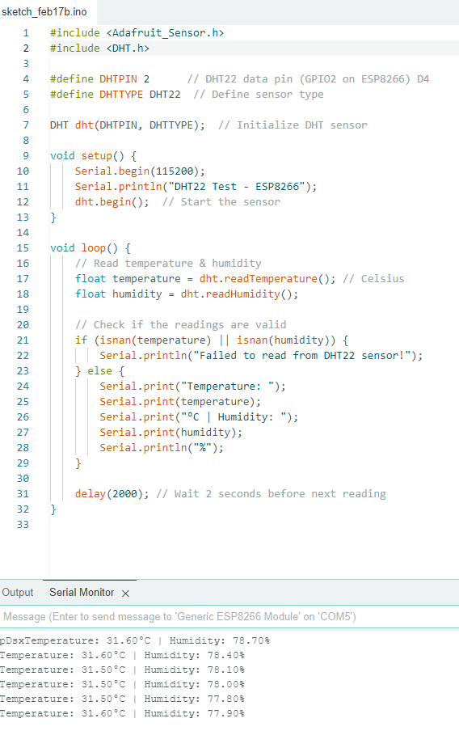

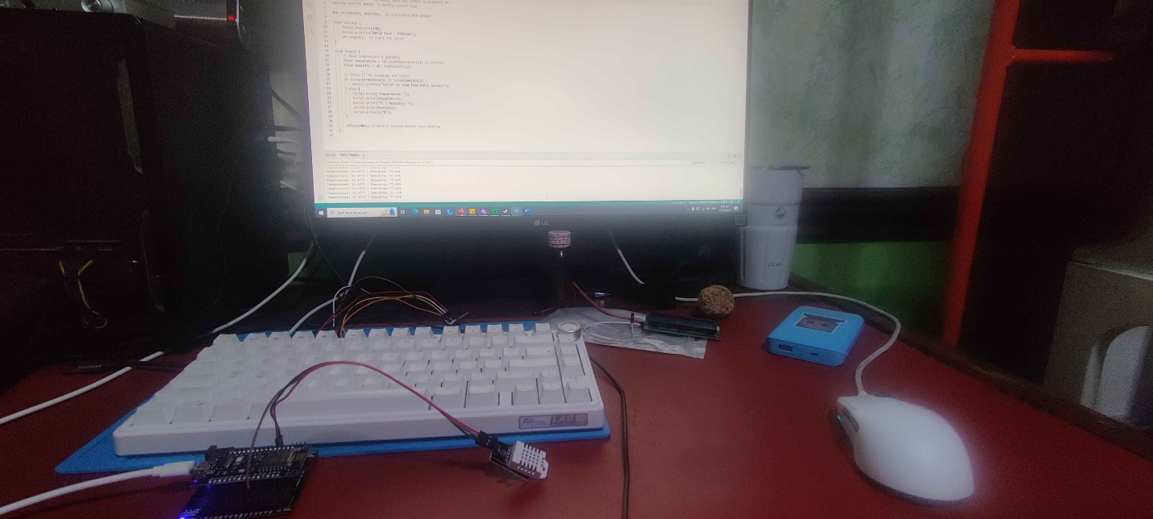

Testing of LCD display:

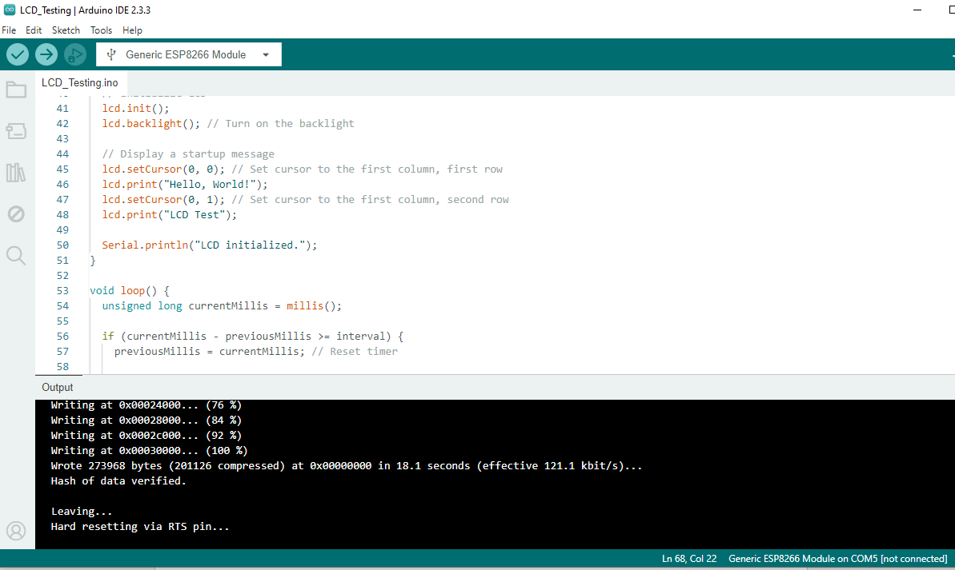

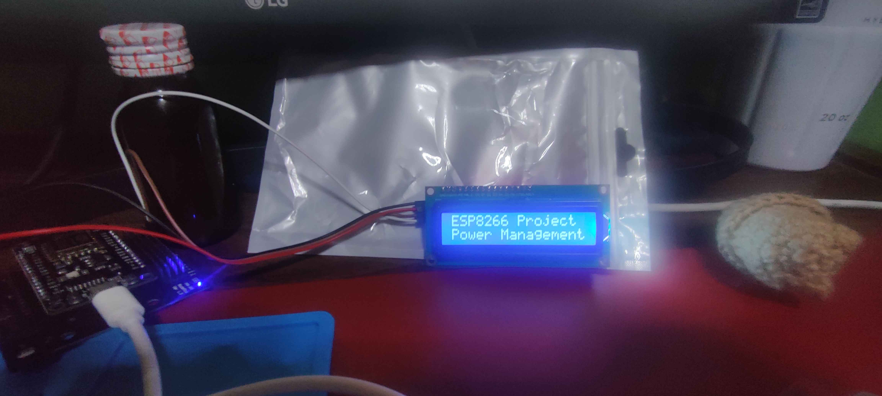

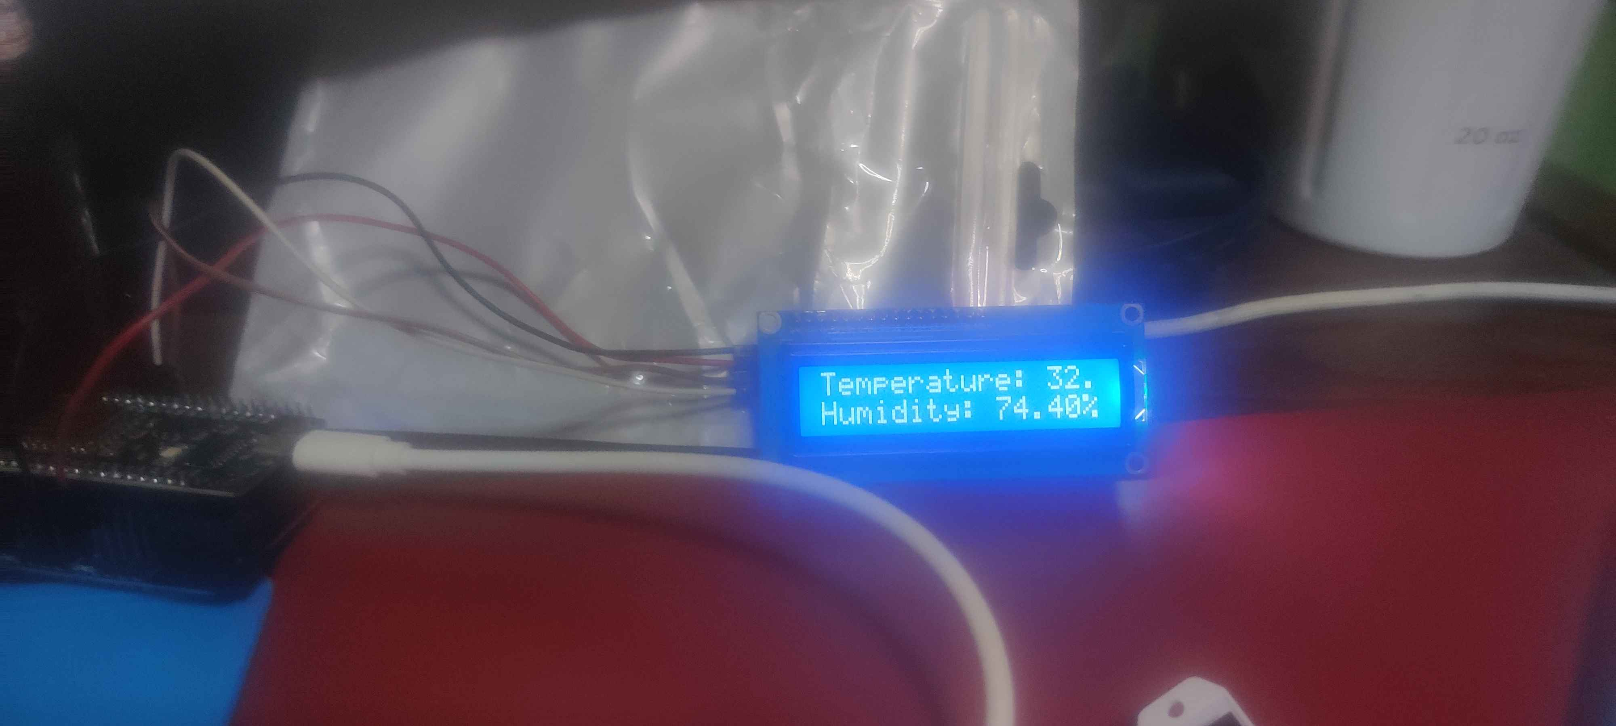

**Comment: Originally, the pic above should be the output of the LCD, but given that the Temperature covers the entire LCD, I shortened it so that more values can be seen in the LCD:**

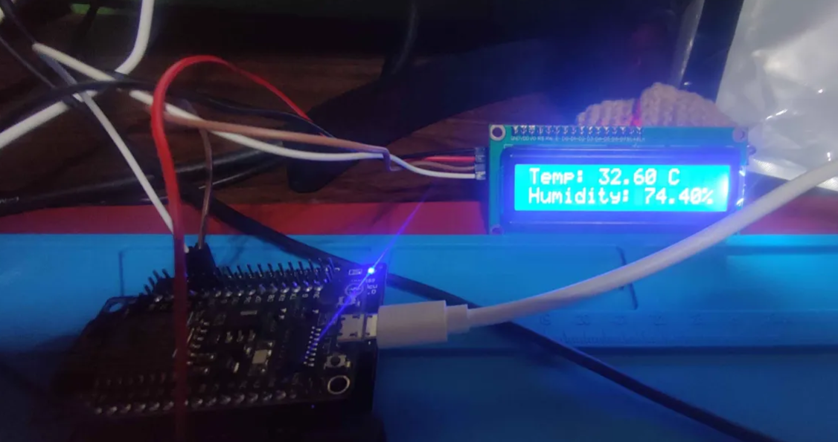

Master code

**Description: Contains the code for all the sensors and the LCD. This code also includes the ThingSpeak (IOT) capability**

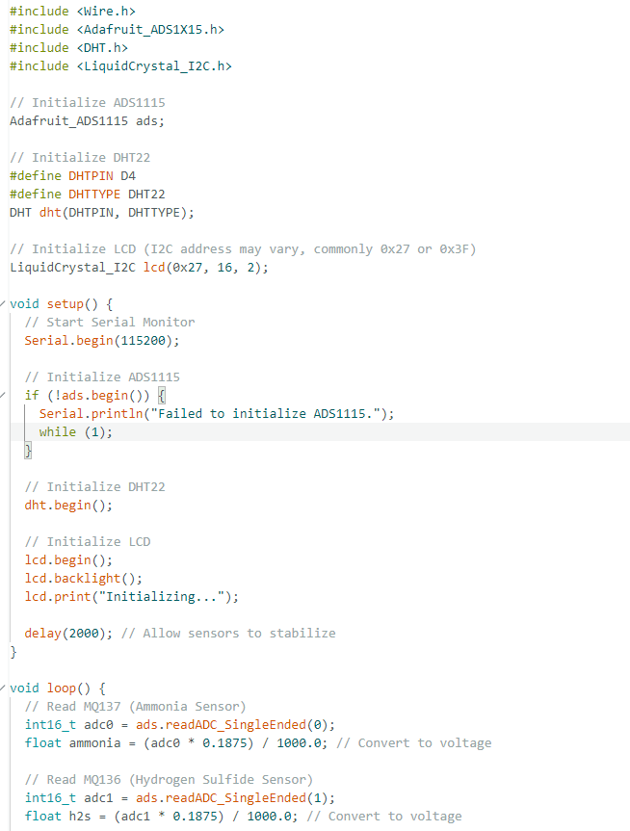

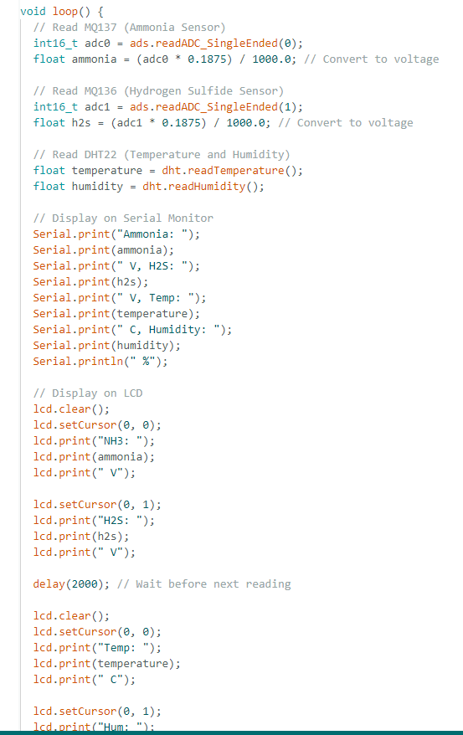

MQ Sensor code:

**Description: Used for calibrating both MQ136 and MQ137**

